mHero TERMS OF REFERENCE
[insert name of MOH and country]

Background:
mHero is a SMS-based communication platform used on basic mobile phones to ensure effective and efficient communications between health workers, [district/county/department] level administrators and the senior health decision makers at the [insert name of country] Ministry of Health (MOH). mHero is an integral component of the country’s health information system, strengthening communication, data sharing, planning and management across the MOH.

Aim:
The roles outlined in this TOR support the implementation of mHero as developed by the MOH [insert name of country]. Below is a graphical representation of these roles.

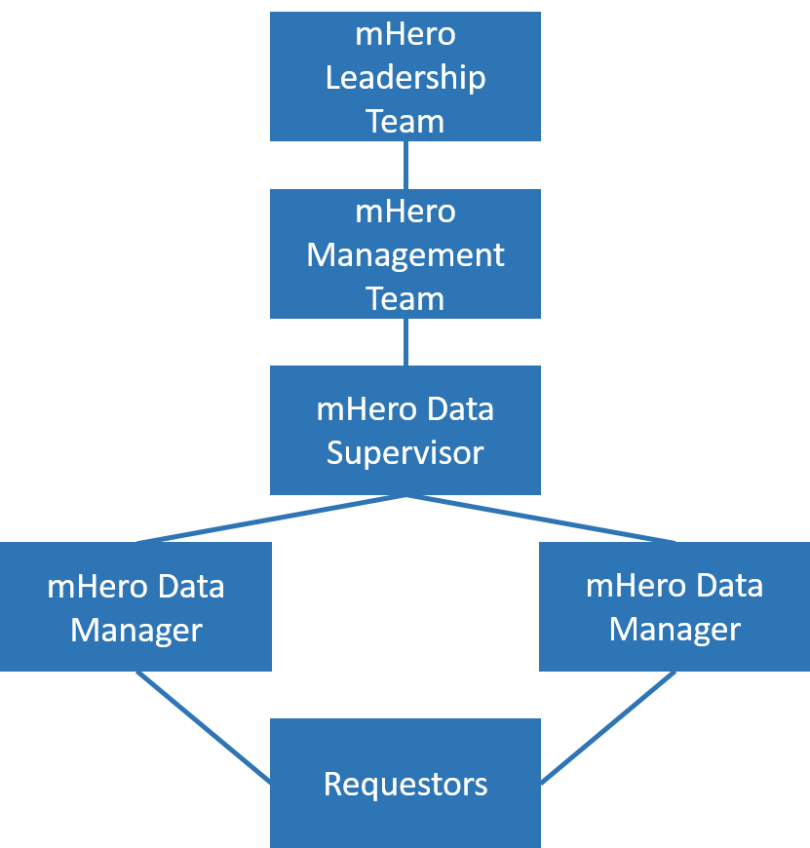

- mHero Data Manager
Role: The mHero Data Manager operates the day-to-day implementation of mHero to ensure the effective and efficient use of the system. The Data Manager represents mHero throughout the MOH, soliciting use cases from [units/directorates/teams] within the ministry and developing corresponding workflows. The Data Manager is responsible for reporting the results of workflows and analysis of data back to Requestors. The Data Manager assists the mHero Management Team by supporting advocacy and awareness raising of mHero with partners both internal and external to the MOH. The Data Manager will identify issues in the implementation of the system and report them to the mHero Supervisor and mHero Management team.

The Data Manager reports to the mHero Supervisor. Some mHero teams may wish to have several mHero Data Managers, depending on the needs of the system’s implementation.

Key responsibilities:
- Conduct day-to-day operations of mHero, following proper standard operating procedures:
  - Work with ministry [units/directorates/teams] to identify and develop Use Cases.
  - Develop, review and revise corresponding workflows in RapidPro or other SMS systems.
  - Initiate workflows in iHRIS and monitor responses in both iHRIS and RapidPro.
  - Troubleshoot problems with messaging as they occur.
  - Ensure the completion and filing of proper Use Case documentation such as:
    - Use Case request forms
    - Use Case Planning, Implementation and Monitoring tool
  - Develop reports on results of workflows and provide the same to the requestor of the use case.
- Report issues and problems with the system that arise in the use of mHero technologies.
- Support the development and revision of the following documents required to build a functional and viable mHero communication system easily integrated into the MOH programs:
  - Standard Operating Procedure (SOP), including policies on mHero applications and governance
  - Terms of Reference (TOR) for Central and [District/County/Department] mHero teams and individual members of mHero Teams
  - Monitoring and Evaluation (M&E) Framework
  - Implementation Plan
- Conduct regular validation of personnel records in the iHRIS database to support effective communication with the health workforce through mHero.
- Contribute to the development and utilization of :
  - mHero sustainability and decentralization plans
  - mHero analytics platform
- Provide inputs for regular updates to the mHero Leadership Team on progress, challenges, and success.
- Take minutes during regular mHero meetings, serving as secretariat to the mHero Leadership Team.

- The mHero Supervisor
Role: The mHero Supervisor oversees the implementation of mHero to ensure the effective and efficient implementation of the system. The Supervisor ensures that mHero is well integrated into the MOH structure and system, in particular the health information system (HIS) framework, and that implementation follows mHero policy and procedures. The mHero Supervisor will represent mHero throughout the Ministry and with partners to raise awareness of the existence and purpose of the platform. The mHero Supervisor will serve as a point person in the Ministry for mHero operations. The mHero Supervisor will take the lead in troubleshooting any issues that may arise with the system and take the lead in reporting on the activities of mHero to upper level management.

The mHero Supervisor oversees the mHero Data Manager and reports to the [Appropriate leader of the Unit/Directorate under which mHero sits, such as Director of HR/Head of HMIS Unit].

Key responsibilities:
- With support from the mHero Data Manager, the mHero Supervisor will lead development and revisions to the following documents:
  - Standard Operating Procedures (SOP), including policies on mHero applications and governance
  - Terms of Reference for [district/county/department] mHero teams and individual members of mHero Teams
  - Monitoring and Evaluation (M&E) Framework
  - Implementation plan
- Provide key strategic insights on the design and development of the analytics platform (with the support of partners).
- Plan and facilitate mHero trainings as needed.
- Support integration of mHero into the HIS Framework, central and [district/county/department] Level Operational Planning and other policies and plans as identified, including coordination with other HIS partners and Ministry leads.
- Support the design of and implement the mHero sustainability and decentralization plan with support from the mHero Data Manager and mHero Management Team.
- Coordinate and participate in field visits to the [district/county/department] for the purpose of awareness creation, planning, establishing mHero [district/county/department] teams, training teams in the operations of the technology, monitoring and supervision of the mHero applications and functions.
- Coordinate advocacy and awareness meeting with stakeholders (external and internal organizations and individuals) with potential of influencing decisions in the interest of accepting, championing and promoting mHero.
- Organize regular mHero meetings with the mHero Leadership Team to discuss challenges affecting implementations, lessons learned and strategies to move the project forward.
- mHero Management Team
Role: The mHero Management Team works together to oversee the implementation of mHero, ensuring that that the platform is well integrated into the Ministry of Health structure and system, that the component technologies are functioning appropriately and that implementation is following mHero policy and procedures. The mHero Management Team will represent mHero throughout the Ministry and raise awareness on the existence and purpose of the platform, as well as be the first point of contact for requests for use of mHero.

The mHero Management Team will coordinate with and report to the mHero Leadership Team.

COMPOSITION OF THE mHero MANAGEMENT TEAM: The membership of the mHero Management Team comprises of individuals that oversee, operate and support the implementation of mHero. These team members may include:
- Director/Unit Head [of the Directorate or Unit in which mHero sits]:
  - Oversees the mHero Management Team and provides key supervision, management and technical insights informing the strategic direction of mHero. Creates awareness on mHero throughout the Ministry and ensures that mHero is in line with and integrated into the health information system architecture.

- mHero Supervisor:
  - Manages the mHero Data Manager, coordinates the implementation of mHero in [insert country name], including daily operational management, awareness raising and ensuring that mHero is in line with and integrated into the health information system architecture.

- mHero Data Manager:
  - Conducts the day-to-day operations and activities of mHero.

- IT [Manager]/Software Developer*
- Provides IT support to the mHero Management Team in terms of hardware and software functionality, ensuring that component systems are functioning appropriately and making modifications and customizations as appropriate.

*The IT Manager/Software Developer will not be a full time member of the team as he/she has other MOH duties. This position could also be split between multiple persons someone with hardware expertise and someone with software expertise.

Key responsibilities:
- Team members will conduct day-to-day operations of mHero, following proper standard operating procedures, as indicated in mHero Supervisor and mHero Data Manager TORs.
- Finalize and approve of the following documents, as indicated in mHero Supervisor and mHero Data Manager TORs:
  - Standard Operating Procedures (SOP), including policies on mHero applications and governance
  - Terms of Reference for [district/county/department] mHero teams and individual members of mHero Teams
  - Monitoring and Evaluation (M&E) Framework
  - Implementation plan
- Oversee use of the analytics platform (with the support of partners) and use the same platform to analyze and present results of responses to the mHero Leadership Team as required.
- Facilitate the planning of mHero trainings as requested.
- Lead the design and implementation of mHero sustainability and decentralization plans.
- Oversee the execution of field visits to [districts/counties/departments] for the purpose of awareness creation, planning, establishing mHero [District/County/Department] teams and training them in the operations of the technology, monitoring and supervision of the mHero applications and functions.
- Advocate for and support the integration of mHero into the health information system (HIS) Framework, Central and [district/county/department] Level MOH Operational Planning and other policy and plans as identified.
- Hold advocacy and awareness meeting with stakeholders (external and internal organizations and individuals) with potential of influencing decisions in the interest of accepting, championing and promoting mHero.
- Provide quarterly updates to the mHero Leadership Team on progress, challenges, and success.

- mHero Leadership Team
Role: The mHero Leadership Team is the overall mHero leadership body that provides strategic direction for the mHero Platform, determining the scope, strategy and operations of mHero within the Ministry of Health. The mHero Leadership team thus works with the mHero Management Team to ensure that mHero is well integrated into both the Ministry of Health structure and systems as well as the daily business practices of the [Units/Directorates] the Leadership Team Members represent. The mHero Leadership Team will receive monthly reports from the mHero Management Team for review and comment.

COMPOSITION OF THE mHero LEADERSHIP TEAM: The membership of the mHero Leadership Team brings together diverse capabilities from different professional backgrounds required to move the mHero activities forward. The Team should have no more than fifteen (15) members and include members from all of the [Units/Directorates] that will utilize mHero, as well as representatives from the ICT [Unit/Directorate], local partners and funders as appropriate. Examples of these team members include:
- Director, Health Information Systems
- Director, Policy, Planning and Information/Strategic Planning/HMIS
- Director, Human Resources for Health
- Manager, Human Resource for Health
- M&E Specialists and HMIS officers
- e-Government Coordinators and mHealth Specialists
- Director, Ministry of Information and Communications
- Manager, ITC
- Director, Maternal and Child Health
- Director, Nutrition
- Director, Primary Health Care
- Partner representation including WHO, CHAI and UNICEF

Key responsibilities:
- Provide strategic feedback on mHero operations and lead the long term vision of mHero as part of the MOH and national health information system (HIS) Framework.
- Provide approval for the following documents:
- Standard Operating Procedure (SOP), including policies on mHero applications and governance
- Terms of Reference for Central and [District/County/Department] mHero teams and individual members of mHero Teams
- Monitoring and Evaluation (M&E) Framework
- Implementation Plan
- Provide key strategic insights on the design and development of the analytics platform.
- Provide feedback and approve mHero sustainability and decentralization plan.
- Provide feedback on the integration of mHero into the health information system HIS framework, Central and [district/county/department] Level MOH Operational Planning and other policy and plans as identified.
- Regularly inform the mHero project team of the current and desired future state of health management information systems (HMIS) processes, systems and needs of the MOH and its various [Units/Directorates].
- Attend monthly or quarterly mHero Meetings with the mHero Management Team to receive updates on the progress of mHero, provide feedback and share information on upcoming workshops, trainings or other events into which mHero should be incorporated.

Review Procedure
The mHero Management Team will meet at least once per week and on an ad-hoc basis as required by the mHero implementation timeline and priorities.

The mHero Supervisor will produce a status report including the following:
- Project plan
- Progress on deliverables
- New issues and risks
- Progress on resolution of issues and risks.

The mHero Management Team will approve the commencement of the next project activity.

