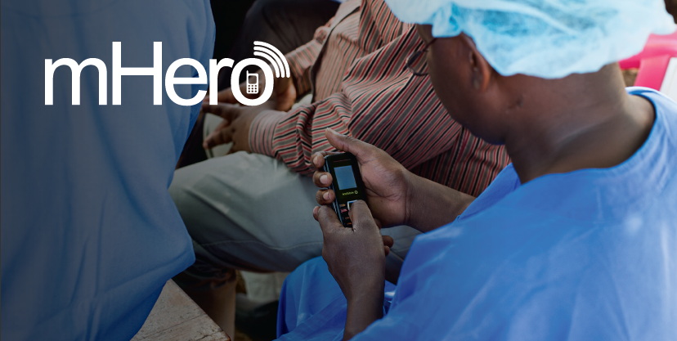

Sample mhero indicators

May 2016

Indicators are tools for measuring the achievement of things such as program activities, processes and outcomes to in order to identify trends and gauge both successes and areas in need of improvement or modification. Indicators for mHero can be used in performance monitoring plans (PMP) or evaluation activities to provide information such as the number of people using mHero or the number of use cases developed.
The indicator matrix below organizes some key program indicators for the mHero project, both quantitative and qualitative. The qualitative indicators are milestones that will track the achievement of results and long-term processes while the quantitative indicators are those things more easily captured with numerical values.
The first column lists the indicator itself, while the second defines it and how it should be measured. The third column, ‘Disaggregation,’ identifies ways in which the data collected for an indicator can be separated for more in-depth analysis, if applicable. The fourth column lists the source of the data needed to inform progress on each indicator and then fifth column notes how often the indicator should be reported on, and by whom. Baseline data, to be included in the sixth column, is collected at the beginning of the project and serves as a basis for comparison with the data acquired throughout the course of implementation. The final column, ‘Targets,’ should be populated with the value for each indicator that defines programmatic success, agreed upon by the project implementation team prior to the start of the project.

Indicator | Indicator Definition and Unit of Measure | Disaggregation | Data Source | Reporting Schedule &  Responsible Person | Baseline | Targets
Project Goal: Support the development and adaptation of mHero in order to rebuild stronger, more resilient health systems
Increased awareness of mHero | Measures level of awareness of mHero by potential users and the project success in disseminating information about the system. mHero users are defined as all cadre of health workers and personnel at MOH. Numerator: number of potential mHero users who indicate on a survey that they are knowledgeable of mHero and can identify three characteristics of the system; Denominator: total number of people surveyed. Unit of measure: number and percent | Type of potential user; level of user Central, regional, local; geographic location (urban/rural) and country | Baseline and end point surveys | Annually, Project Technical Advisor | HWs: XX%  MOH: XX% | HW: XX%  MOH: XX%
Global mHero supported
Number of strategic partners leveraged | Number of strategic, peer, or international organization partners leveraged to address specific critical barriers of the emergency epidemic context (ex: WHO, MSF, etc.) Numerator: number of partnerships.  Unit of measure: number | By country | Project records , Meeting minutes, subagreements | Annual, Project Technical Advisor | Number: X | Number: X
mHero policy and procedures developed and implemented
SOPs and agreements completed | Measures progress made towards establishing policies to govern the roll out and implementation of mHero and to support its transition to the host country. To be completed, the following documents must be completed and approved: 1. mHero internal SOP; 2. mHero integration policy; 3. Data sharing agreement; 4. mHero external partners SOP  Numerator: number of policies finalized  Denominator: total number of policies  Unit of measure: number | N/A | Program records and documents | Quarterly, Project Technical Advisor | Number: X | Number: X
Indicator | Indicator Definition and Unit of Measure | Disaggregation | Data Source | Reporting Schedule &  Responsible Person | Baseline | Targets
Enhanced two-way communication for HWs through mHero implementation
Number of use cases initiated by the MOH | Measures progress made in mHero deployment by counting the number of use cases.  Numerator: number of use cases initiated  Denominator: N/A  Unit of measure: number | N/A | mHero platform analysis | Quarterly, Project Technical Advisor | Number: X | Number: X
Number of connected health workers that regularly input health information via digital data platform | Measures number of health workers who respond to the first question in a SMS workflow  Unit of measure: number | geographic location, gender,  cadre, etc. | mHero platform | Quarterly, Project Technical Advisor | Number: X | Number: X
Number of health workers that regularly receive health information via digital data platform from Ministry of Health | Measures the number of health workers to whom the MOH sent SMS Unit of measure: number | geographic location, gender,  cadre, etc. | mHero platform | Quarterly, Project Technical Advisor | Number: X | Number: X
Strengthened systems interoperability and capacity to use data for decision-making
Number of interoperable HMIS systems used to enable/promote data-based decision making | Measures the number of interoperable HMIS systems. Increased interoperability of existing HIS components will improve accessibility of health worker data for MOH health workforce decision making  Unit of measure: number | N/A | MOHS records | Annually Project Technical Advisor | Number: X | Number: X

© IntraHealth International. This document is made available under a Creative Commons Attribution-ShareAlike 4.0 International: https://creativecommons.org/licenses/by-sa/4.0/
uckett BenDo
This information is made possible by the generous support of the American people through the United States Agency for International Development (USAID). The contents are the responsibility of IntraHealth International and do not necessarily reflect the views of USAID or the United States Government

CONTACT
Amanda Puckett BenDor
Digital Health and Knowledge Management Advisor;
mHero Global Coordinator
apuckett@intrahealth.org

